

Off-Grid Solar Power System Proposal

For

Mr. Daniel Coore

Date: 23rd March, 2013

23rd March, 2013

Subject: Off-Grid Solar Power System for Residence

Mr. Daniel Coore,

After conducting a detailed site inspection of your residence, we were able to design an off-grid solar power system that will provide, on average, 337 kWh of power a month.

Based upon the usable roof space at your residence and your current usage of electricity on a monthly basis, we would recommend installing 3Kw off-grid solar power system. Please find attached an estimate to install a 3Kw polycrystalline off-grid solar power solution. We can provide you with an estimate for a monocrystalline system should you require it. Please note that the system can accept more solar modules if you choose to increase the size of the solar array and consequently, your monthly electricity production.

A solar array (multiple solar modules) will generate a certain amount of power for every month of the year given:
- Average solar radiation for the intended installation site for the year (Jamaica)
- Pitch of the roof or intended installation stand
- Bearing of the roof or intended installation stand
- Efficiency of the solar module and inverter being used

During our site inspection we gathered this necessary data and based on the aforementioned inputs we have arrived at the following annual electricity production figures (averages) for the 3Kw installed on the usable section/s of your roof:
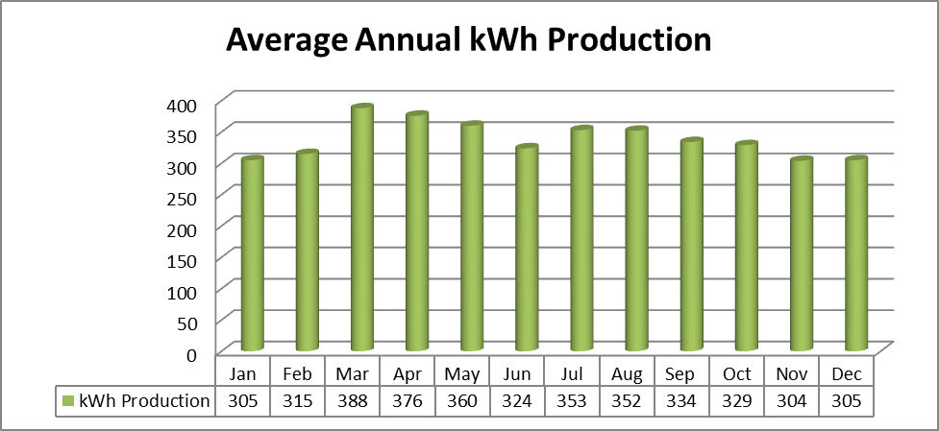

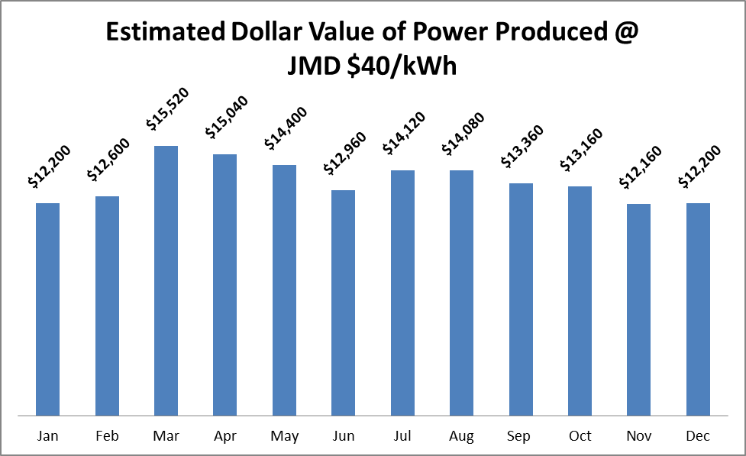

Month | kWh Production | Estimated Dollar Value of Power Produced @ JMD $40/kWh | Estimated Dollar Value of Power Produced @ USD 0.44/kWh
Jan | 305 | $ 12,200 | $ 134
Feb | 315 | $ 12,600 | $ 138
Mar | 388 | $ 15,520 | $ 171
Apr | 376 | $ 15,040 | $ 165
May | 360 | $ 14,400 | $ 158
Jun | 324 | $ 12,960 | $ 142
Jul | 353 | $ 14,120 | $ 155
Aug | 352 | $ 14,080 | $ 155
Sep | 334 | $ 13,360 | $ 147
Oct | 329 | $ 13,160 | $ 145
Nov | 304 | $ 12,160 | $ 134
Dec | 305 | $ 12,200 | $ 134
AVG | 337 | $ 13,483 | $ 148
TOTAL | 4,045 | $ 161,800.00 | $ 1,778.02

Simple analysis that does not take into account inflation and assumes a constant kWh rate of JMD $40
Pricing
If you were to purchase the 3.1Kw off-grid solar power system using cash the total installed cost of the system would be USD $10,453.66

If you were to make a 10% equity investment towards the system, NationGrowth Micro Finance could finance the system for a period of 8 years. The monthly payment for the system would work out to be approximately JMD $19,076 (This figure represents a rough calculation and not a final figure).

Repayment Analysis

System Name Plate Capacity: 3Kw (3,000W)

Total Installed Cost of System (USD): $10,453.66

Assumptions for Financial Analysis:

Average Annual kWh Production Year 1: 4,045

Average Annual kWh Rate Year 1 (USD): $0.40

Annual Increase in kWh Rate: 10%

Annual Inflation of Jamaican Dollar: 15%

Repayment on System (Years): 4.3
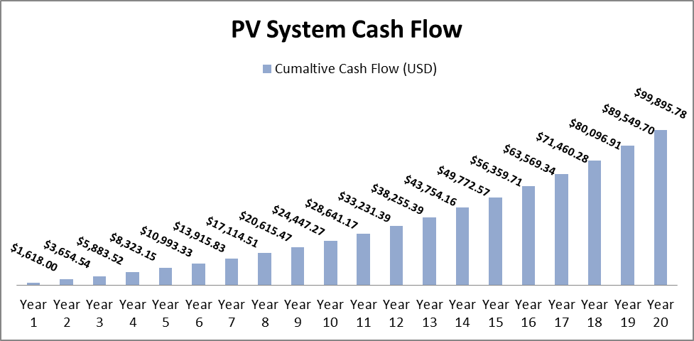
Component Parts
IREE Solar only utilizes high quality component parts made by trust worthy and experienced manufacturers in order to ensure maximum power production and longevity of your solar power system.
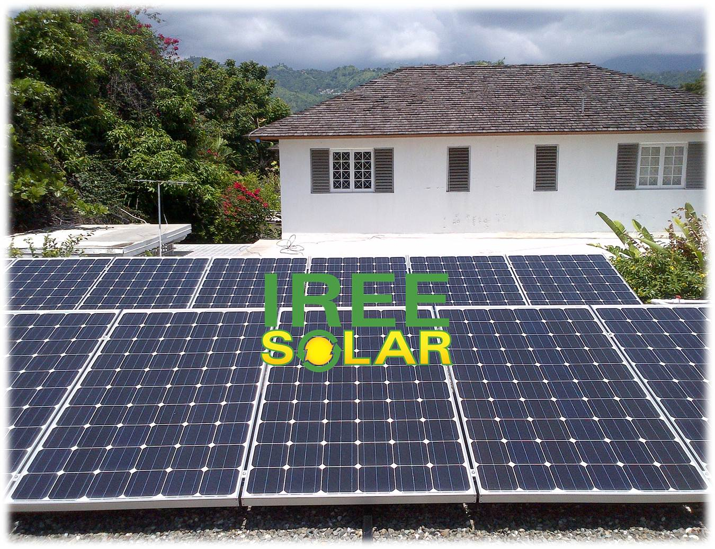
Solar Modules/Panels:
IREE Solar is committed to offering the highest quality products to our clients and as a direct result of this philosophy we utilize high quality US and German made solar modules/panels. One of our main suppliers is Suniva, an American manufacturer of high efficiency crystalline silicone photovoltaic solar cells and high power solar modules. Suniva cells are able to operate at conversion efficiencies of 19% (monocrystalline) which put them in a class of their own while still remaining affordable. All Suniva modules/panels are backed by a 10 year workmanship warranty and 25 year linear performance warranty ensuring high performance for the lifetime of the module/panel. All modules/panel frames are made from non-corrosive marine grade aluminium and have undergone salt water spray tests in German testing facilities.
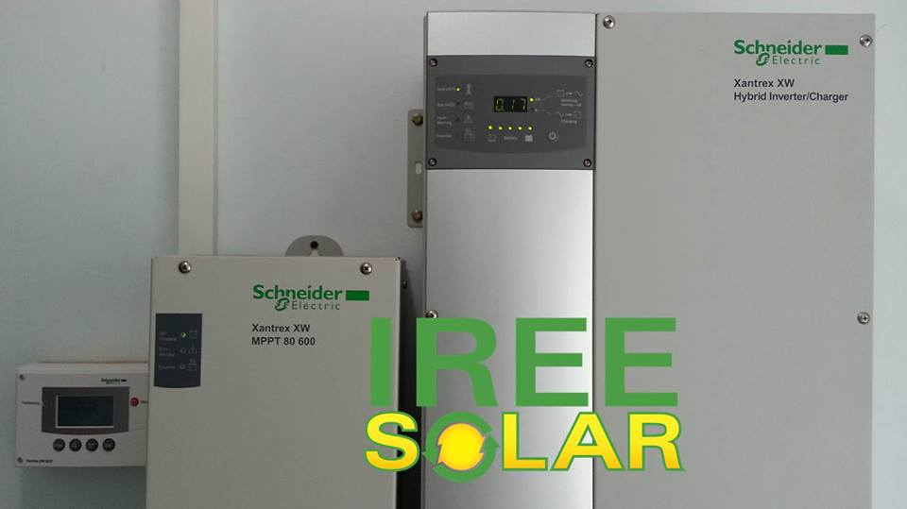
Inverters:
Combining high quality modules/panels with high quality inverters ensures maximum power production during prevailing weather conditions which subsequently decreases the repayment time on your system. IREE Solar utilizes many of the leading off-grid and hybrid inverters manufactured by Schneider Electric, Outback Power, Magnum Energy. These trust worthy inverters and inverter chargers can be relied upon to provide you with power whenever required and are backed by robust warranties.
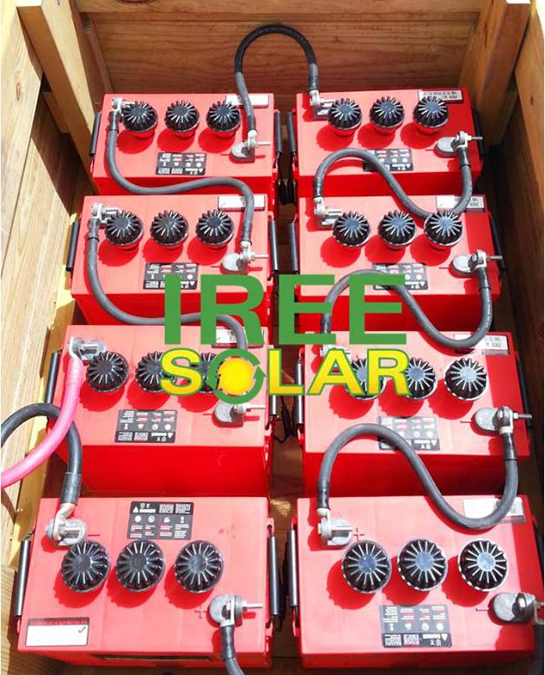
Batteries:
Producing your own power from renewable energy sources and then not being able to store and retrieve that power in an efficient manner can result in unnecessary hassle and safety hazards. IREE Solar only uses deep cycle batteries manufactured by either Rolls/Surrette or Trojan Battery due to their high build quality, extensive use in all weather conditions around the world for decades and their unmatched customer support.

Racking & Hurricanes:
All our systems are installed using SnapNrack or DPW Solar aluminium racking systems which guarantee that your solar panels are securely attached to your roof. This racking system is wind tested for severe wind speeds up to 150 mph. That being said, the beauty of the SnapNrack or DPW Solar system is that it allows one to easily mount solar panels due to the easy to use clamps that hold the panels to the rails. This also means that it is very easy to remove the solar panels from the rails if necessary (in the case of a fast approaching hurricane), all one needs to release the panels from the rail system is a socket set.
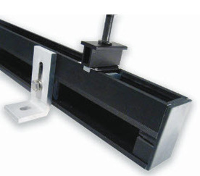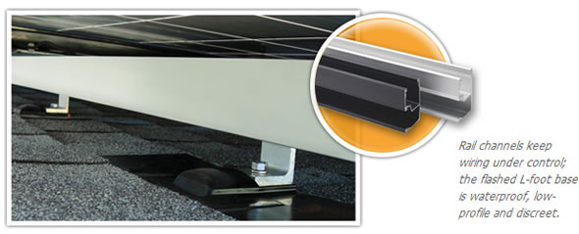
SnapNrack Rail with L-Bracket Roof Attachment & Solar Panel Mid Clamp
Some installers actually drill holes into your solar panels to mount them to your roof which is not recommend as damage to the solar panels is quite likely to occur during the process and drilling holes into a solar panel’s frame will normally void the warranty from the manufacturer.

Should you require any additional information or wish to view our demo system, please contact us and we would more than happy to assist you.

We look forward to your favourable response.

Regards,

Alex Hill
Managing Director

